Lewis Claus Lenz

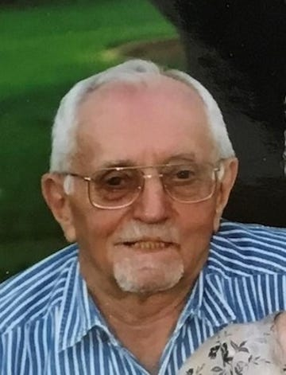

Lewis Claus Lenz, 96, of Mesa, Arizona, passed away on February 6, 2024. Lew was born in Denison, Iowa on May 21, 1927. Lew was an Army veteran and a graduate of South Dakota State with a BS in Engineering. He worked for the FHWA for nearly 25 years in the US and overseas. He retired to Mesa, Arizona where he lived with wife Cora for over 30 years in the home he always dreamed of building.
He is survived by his wife of 75 years Cora Mae; Children Donna Jean Jaeger, Robert Lewis (Sandy), and James Alan (Lydia); along with seven grandchildren, and five great-grandchildren.
A Celebration of Life will be held on Friday, March 1, 2024, at 1:00 p.m. at Mariposa Gardens, 6747 E Broadway Rd, Mesa, AZ 85206. (https://www.dignitymemorial.com/obituaries/11658334). A gathering will follow the memorial at the Santan Center in Sunland Springs Village at 2820 S. Springwood Blvd.
Posted online on February 20, 2024
Published in The Arizona Republic

