OBITUARY

Donald G. Johnson

August 28, 1941 – April 24, 2024
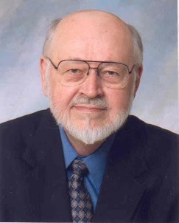

It is with great sadness that the family announces the passing of Donald Gene Johnson of Noblesville Indiana on April 24, 2024. He was born on August 28, 1941 to John and Helen Johnson of Peoria, Illinois. He was preceded in death by the love of his life, Noreen Dickers Johnson. They met at Bradley University and married on April 16, 1966. He was the loving father to two children Michael (Laurene) and Amy Johnson. He also has three adoring grandchildren: Steven, Mason, and Sophie.
Don received his Bachelor of Science in Civil Engineering in 1964. After graduation, he was employed by the Federal Highway Administration and was sent on assignments all over the country. He was eventually promoted to the Indianapolis Office of the Federal Highway Administration and settled in Indianapolis. He was the Planning and Research Engineer. He remained there until retirement in 2001. He then went to work at Purdue University as the Program Manager for the Institute for Safe, Quiet and Durable Highways. He remained there for several years until his second retirement. He was proud to be a registered professional in both Illinois and Indiana.
Don was very well known for his extremely kind heart. He was always there for his children with great advice and support. He enjoyed providing history education to his children and grandchildren. Mason especially enjoyed his history lessons and long discussions... His family and friends will miss his dry wit, great advice and honesty. He has been described as loving, gentle, sweet and funny.
Services for Don will be held at Leppert Mortuary of Carmel on May 1, 2024 with visitation at 1:00 pm.
Family and friends are invited to the Celebration of Don's life at 3:00pm. All are invited the cemetery after the service. In Lieu of flowers, memorial contributions are suggested in Don's name to Parkinson's Foundation or to Down Syndrome Indiana.

