Lubin Mariano Quinones

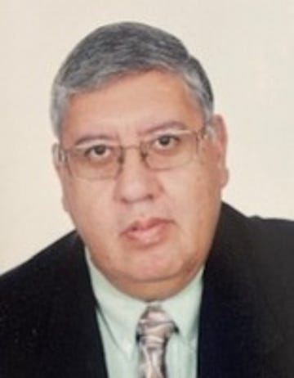

LUBIN MARIANO QUIÑONES passed away November 26, 2024, at the age of 68. Born in Las Cruces, New Mexico on November 16, 1956, to Lubin G. and Socorro R Quiñones. Lubin was the eldest of three sons and grew up in Mesilla Park, New Mexico. He attended Mesilla Park Elementary, Zia Middle School and Las Cruces High School, graduating in 1975. Lubin earned a bachelor’s degree in civil engineering from New Mexico State University in 1980.
He began a thirty-five-year career with the Federal Highway Administration in 1980 as a Highway Engineer Trainee. After graduation from the training program, he worked on the Replenishment Housing Program for the I-105 (Century Freeway) project in the Los Angeles area. During his professional career, Lubin worked and lived in California, Kuwait, South Dakota, Texas, Oklahoma, Puerto Rico, and Iowa. In 2009 he became the Federal Highway Administration Iowa Division Administrator. During his career, Lubin received numerous awards including the Secretary’s Partnering Award, the Heartland Award, and the Administrator’s Superior Achievement Award.
Lubin met a lifelong goal of traveling around the world prior to retirement in 2015 and return to Las Cruces. A devoted son, he spent much of his time with parents Lubin and Socorro. After his father passed away in 2017, he and Socorro spent most days together. He drove her to mass, to visit family and friends. In the final days of her life, Lubin dedicated himself to making sure she was comfortable and well cared for.
An exceptional son, brother, uncle, nephew, cousin, godfather, friend and colleague, Lubin was quiet, reserved, kind-hearted, generous, intelligent, and resolute. He had a dry sense of humor, valued hard work, dedication, and loyalty.
Lubin is survived by brother, Marcos Quiñones (Ophelia); chosen sister, Lilia Lopez (Fernando; nieces and nephews, Stephanie Quiñones, Micheal Quiñones, Sierra Watkins-Quiñones, Mason Quiñones; great-nephew, Ryder Olmstead; aunt, Josefina “Chepis” Cuellar; uncle, Oscar Ruiz, and several beloved cousins. Preceded in death by mother, Socorro R. Quiñones, father, Lubin G. Quiñones and brother, Miguel R. Quiñones.

