Clarence Bennett
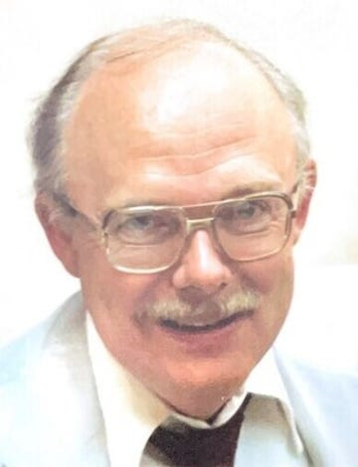

Clarence Eugene Bennett, age 87, peacefully entered eternal rest on October 24, 2023.
Clarence was born to the late Clarence and Bonnie Husk Bennett, a coal miner and homemaker, respectfully, in Marion County, West Virginia on October 11, 1936. He was known by the endearing nicknames of “Sonny” and “Bruno” over the years during his childhood and youth in rural West Virginia. He earned a bachelor's degree in Civil Engineering from West Virginia University, graduating first in his class. He then began a career as a bridge designer with the West Virginia Highway Department. Soon afterwards he met and married his beloved wife of 62 years, Mary Lou Reece, in 1959, and the couple had two daughters.
Clarence relocated his young family to the Northern Virginia area, continuing his career with the Federal Highway Administration, designing bridges and tunnels. Another move followed to New Jersey, where Clarence focused on bridge and highway design. In 1967, he was offered the opportunity to relocate to Tennessee with the FHA. He prided himself on making the move to the beautiful southeastern United States, never having visited before. Finally in 1968 while employed full time, he fulfilled his goal of attending law school, earning the Doctor of Jurisprudence degree in 1972 from the Nashville School of Law. Ever the discerning student, he graduated again at the top of his class. One of his classic quotes about education over the years was “I loved sports but couldn't compete, so I competed in the classroom”.
Clarence retired at age 55 after a fulfilling career with the Federal Government, then soon pursued a second career as a consultant and expert witness in accident reconstruction. He reveled in the opportunity to combine years of experience in engineering with a passion for the legal field. He spent many years boating and fishing on Percy Priest lake, cheering on the Tennessee Titans, and playing cards with his long-time Poker buddies.
He was a lifelong learner, demonstrating that knowledge is power. A memorable trait was taking notes on paper because “a short pencil is better than a long memory”. His effective advice for success and productivity was “nothing is going to happen unless you make it happen”.
Clarence was a wonderful husband, father, and cherished “Papaw” to his grandchildren. He is survived by his wife, Mary, his daughters Susan Bennett, Julie Fette (Chris), grandchildren Reece Bennett, Eva Fette and Cara Bennett. He is predeceased by his parents and sister, Barbara Bennett. The family is forever grateful to Mary Scott, his caregiver and friend.
To honor Clarence's wishes, a private family memorial service will be held at a later date. In remembrance of his life, the family requests that any donations be made to a charity of your choice.

