Obituary: Sondra J. (Partridge) Fairbrother
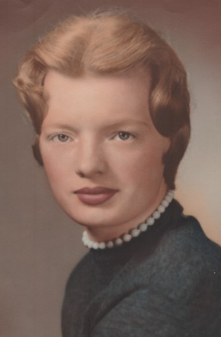
Sondra J. (Partridge) Fairbrother
MOUNTAIN HOME, Ark. – Sondra J. (Partridge) Fairbrother passed away unexpectedly in Mountain Home, Ark. on Feb. 26, 2024 at the age of 85 years old. She was born in Augusta to Linwood V. Partridge and Madeline (Smart) Partridge. Linwood was an artist and illustrator for the State of Maine and former president and chairman of the fund drive that purchased the Harlow Gallery building in Maine and was president of the Kennebec Valley Art Association in 1964.
Sondra and her sister, Sally, were very young when they lost their mother, Madeline and infant sister, Patricia.
Sondra attended Cony High School where she met her husband, Richard Fairbrother. They were married 67 years. She raised four children and the family moved frequently to different states due to her husband’s occupation.
She loved to cook and was known for her donuts (Marjorie Standish inspired) cinnamon rolls, pies, and other pastries. She loved all animals and they were always drawn to her.
Sondra touched many lives with her kind and generous spirit, always thinking of herself last. Her memory will be cherished by those who knew her and all who met her. She was a wonderful listener, always patient, and people felt instantly welcomed by her. She was the sweetest mother a child could ask for and she’ll be deeply missed for the light she brought into this world and our family.
Sondra was preceded in death by her parents; and her sister, Patricia; her stepmother, Marian (Miller) Partridge; her sister, Sally (Partridge) Leavitt and brother-in-law, James Leavitt; and her children Lynne G. Fairbrother and Mark V. Fairbrother.
She is survived by two of her daughters, Brenda Fairbrother and Laurie Fulmer (Ben) of Mountain Home, Ark.; and her brother-in-law, Robert Fairbrother (Barbara) of Augusta; her nieces Shannon Pulsifer and Nicole Leavitt-Wadleigh, and her nephews T.J. Leavitt and Brett Fairbrother; and her cousin, Dick Partridge (Susan) of Augusta.

