Albert John Gallardo
1927 - 2023
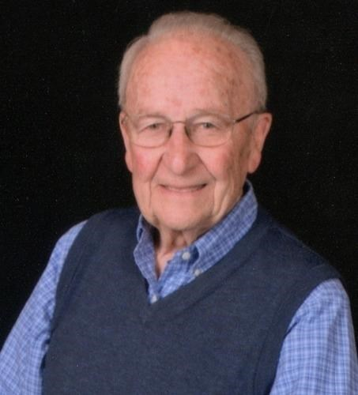

Albert Gallardo Obituary
Albert John Gallardo
April 8, 1927 - June 25, 2023
Age 96 years.
A resident of Sacramento, CA for 65 years. Predeceased by his beloved wife of 45 years, Margaret T. Gallardo. Survived by his children, Albert Jr., Susan, and Julie, daughter-in-law Cathleen, sons-in-law Mark Freitas and Russell Ost, grandchildren Nicholas Gallardo, Caitlin Gallardo (Omar Sebti), Elyse Freitas (Beth Tweedy), Nina Freitas (Robert Cote), and Emily and Michael Ost, and great-grandchildren Cyrus Sebti and Alanna Freitas.
Al served in the US Navy during World War II. He graduated from UC Berkeley and enjoyed a 45-year career as a Civil Engineer during which he surveyed, designed, and served as a senior administrator overseeing the funding and construction of most of California's freeways and highways. It is no exaggeration to say that there are few roadways in our state that do not have Al's handprint on them. He retired as a District Engineer from the Federal Highway Administration and then served as the first Executive Director of the Alameda County Transportation Authority. He was awarded the Federal Secretary of Transportation's Meritorious Achievement (Silver Medal) in 1978.
As a leader in Sacramento's Civil Engineering community, he served as local president and then as Sacramento's representative on the National Board of the American Society of Civil Engineers.
In addition to Professional activities and honors, Al actively supported his children's activities and local community with service and leadership on Little League, Camp Fire Girl, Girl Scout, and other neighborhood and church committees. He enjoyed serving cioppino for many years at St. Mary's and was a tenor in its choir. He proudly was a "Spring Flinger", singing and dancing his way with the friends he made through the annual Spring Fling fundraiser that supported Jesuit High School for more than 15 years. He was a fifteen-gallon donor at the Sacramento Blood Bank.
In retirement, Al volunteered at the California State Railroad Museum and offered counseling for the Small Business Administration under its "Service Corps of Retired Executives" (SCORE) program. He biked many miles with his dear, later-life companion, Catherine McCormick, and continued biking on the American River Parkway after her passing in 2010, only giving up cycling in his early 90s. Al was a life-long learner and regular participant in the programs offered by the CSUS Renaissance Society, where he honed his Spanish-speaking skill and engaged in many topical forums. He enjoyed traveling and local adventure and remained a loyal fan to his UC Berkeley California Golden Bears, even though he did not get to see them return to the Rose Bowl.
A memorial mass to celebrate Al's life will be held on Saturday, August 12, 2023 at 11:00 a.m. at St. Mary's church in Sacramento. Al had many interests; if you would like to commemorate him, donations may be made to the Sacramento Railroad Museum, American River Parkway Foundation, or Jesuit or Christian Brothers High Schools. Arrangements by W.F. Gormley & Sons.
Published by The Sacramento Bee on Jul. 23, 2023.

