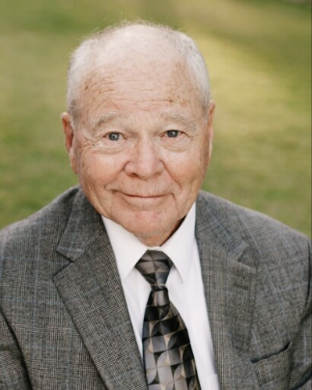 James Henry Lamb
James Henry Lamb, aged 85, passed away peacefully on August 12, 2024, in Saint George, Utah. He is survived by his beloved wife of nearly 60 years, Bonny Marie Davidson Lamb, and their six children: Jenni Nielsen, Devin Lamb, Dara Salmond, Ryan Lamb, Janelle Morris, and Shauna Leonard. He is also survived by 34 grandchildren, 5 great-grandchildren (and counting), as well as his younger sister, Karen Peterson.
Jim was born in Henryetta, Oklahoma, on April 7, 1939, to James Henry Lamb Sr. and Viola Hendrix Lamb. Shortly after the Great Depression, at the age of three, Jim and his family embarked on a journey from Oklahoma to California. Along the way, they stopped at the Mesa, Arizona Temple, where Jim's parents were sealed, and Jim was sealed to them. The family eventually settled in Los Angeles, California, where Jim began his education. They later moved to Mira Loma, California, where Jim attended Jurupa Junior High School. In the 9th grade, he served as Student Body Vice President. Jim completed high school at Riverside Polytechnic High School and went on to attend San Bernardino Valley Junior College. He earned his Bachelor of Science in Engineering from San Diego State College, graduating with distinction.
This education paved the way for a 37-year career as a Civil Engineer with the Federal Highway Administration. During his final training assignment in Carson City, Nevada, he attended church, where Bill Franklin, impressed by Jim's good looks, introduced him to his wife’s twin sister, Bonny. Bonny was quickly charmed by Jim's wavy blonde hair and red sports car. Their courtship led to marriage in the Los Angeles Temple on February 12, 1965.
Jim and his family forged lifelong friendships in Citrus Heights and Newcastle, California; Littleton, Colorado; and Rigby, Idaho, creating countless happy memories as the family grew. Over the years, Jim served faithfully in many church positions, always demonstrating his commitment and dependability. Together, Bonny and Jim served in the Idaho Falls Temple for two years. They then served for a year-and-a-half as Welfare Services Missionaries in Kenya, Ethiopia, and Uganda from 2005-2006. Their home in Rigby, Idaho, was the heart of family gatherings for 20 years, especially during the annual 4th of July reunions. With 8 acres for camping, a pond for swimming, a stream for floating, delicious food, and talent shows, the Rigby house was a source of joy and cherished memories.
In 2015, Jim and Bonny moved to Saint George, Utah, seeking warmer weather and proximity to family. They found a welcoming community in a branch of wonderful retired brothers and sisters who were caring and giving.
While this overview recounts where Jim was and what he did, it cannot fully capture the man he was to those who knew him best. To his children, he was a devoted family man who spent time reading to them, teaching them how to throw and catch a baseball, taking them on backpacking and fishing trips, and ensuring everyone knew how to mow the lawn. He taught the value of a dollar, how to play a decent game of liar's dice, and warned never to pick up a wooden nickel. Punctuality was important to him, especially when leaving for church. He had a tendency to use the words “man,” “rats,” and “gadzooks” in place of more colorful language. He enjoyed a good can of smoked oysters or a slice of summer sausage on a cracker with cheese. If you didn’t understand your math homework, he would patiently tutor you, often saying, “I like to draw a picture” when it came to story problems. Though a man of few words, he enjoyed whistling and singing tunes like “Swing Low, Sweet Chariot” or “Nobody Knows the Trouble I’ve Seen.” Despite his occasionally Eeyore-like statements and sometimes pessimistic outlook, we all knew how much he loved us.
We celebrate his life and achievements, remembering him as a man everyone could depend on and as a man of faith. Even as his breaths grew shorter, he had the strength to sing the hymns “How Great Thou Art” and “God Be With You Till We Meet Again.” Until we meet at Jesus’ feet, God be with you, Dad. We love you!

