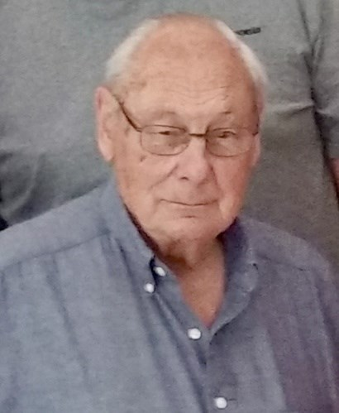
Roscoe H Crowell
September 15, 1929 - January 31, 2025
Roscoe was the oldest child born to Ralph E Crowell and Eleanor (Hull) Crowell in Missoula MT. Roscoe and his younger brother David spent their formative years growing up in a multitude of places, where Ralph's job with the Forest Service took them- From Montana to Duluth MN, to East Tawas MI, and to Springfield Missouri- where Roscoe's mother taught him to drive while delivering telephone books.
Roscoe graduated High School in 1948 in Springfield Missouri.
Roscoe worked for the forest service after graduation until he was drafted by the army. He spent 18 months in Korea during the war fighting with an artillery unit.
After his honorable discharge from the Army Roscoe went to work for the Bureau of Public Roads. While working on a project in Southern Utah he met the Love of his life, Marilyn Whitlock. Roscoe and Marilyn were married on October 3, 1959.
Roscoe continued to work for the Bureau of Public Roads while obtaining his degree in Civil Engineering from the Missouri School of Mines.
From 1959-1967, Roscoe and Marilyn moved 32 times with the Federal Highway Administration training program-They spent time in Utah, Colorado, New Mexico, Texas, Missouri, South Carolina, Portland Oregon, Sacramento California, and finally landed in Pierre SD in 1967, where they spend the next 30 years raising their family, attending Swim Meets, being a Boy Scout troop leader, and tending their massive garden.
While living in Pierre, Roscoe fulfilled his dream of earning his private pilot's license. Often, he would fly from Pierre to Huron, Rapid City, Aberdeen or Bismarck ND, taking one or more of the children with him to attend Swim meets. Roscoe was an active parent with Pierre Swim Team, and helped organize the Oahe Swim during Oahe Days in the 70's and 80's.
After Roscoe's retirement in 1989, he and Marilyn enjoyed traveling across the country to visit friends and family members. They traveled twice to South Korea, once for an Army reunion tour, and once to spend time with their oldest son Scott and his family.
Roscoe and Marilyn left Pierre in 1997 and lived for a short time in Logan Utah, and eventually moved to Gardnerville Nevada in 1999 to be close to their growing brood of grandkids.
Roscoe was able to realize several more dreams while living in Gardnerville- taking part in the Hot Air Balloon festival and getting his first Hot Air Balloon ride.
With their sons Don and Mark playing the roles of Chauffer and tour guide, Roscoe and Marilyn were able to continue traveling around Utah, Nevada, California and Washington.
Roscoe celebrated his 90th Birthday, and he and Marilyn's 60th Wedding Anniversary with a trip to Green Bay Wisconsin. He was able to watch the Green Bay Packers defeat the Minnesota Vikings at Lambeau Field with extended family. The adventure continued with a visit to the Mackinac Bridge, a stop at his childhood home in East Tawas Michigan, and completed with a tour of the Ford Factory in Detroit Michigan.
Roscoe and Marilyn were blessed to have all 5 of their kids, and all their grandkids help celebrate Roscoe's 95th birthday in Gardnerville.
Roscoe passed away surrounded by family on January 31, 2025. Roscoe was preceded in death by his parents and younger brother. Roscoe is survived by his wife, Marilyn, children Scott (Young-Mi) Crowell,, Mark Crowell, Jeff (Shelly) Crowell, Don (Starr) Crowell, Lori ( Bryan) Stahl; Onida SD and 11 grandchildren.
The family will have a private memorial at a later date.

