William "Bill" H. Stouder
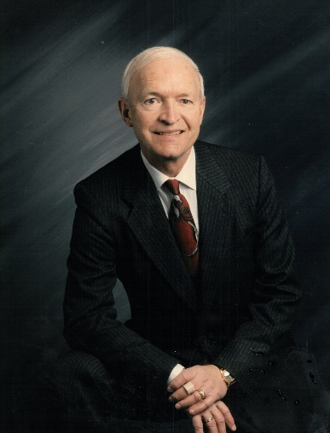

SEPTEMBER 18, 1939 – JUNE 5, 2024
William H. Stouder “Bill”, 84, of Littleton, Colorado passed away on June 5, 2024, with his loving wife Jane by his side.
Bill was a fun-loving person, quick with a joke and happy to be with others. Bill was born in Auburn, Indiana to Earl and Adah Stouder, the 2nd of three children. After graduation from High School, Bill bought his uncle’s truck and drove to Alaska to explore and enjoy the great outdoors. After a year in Alaska, he returned to Indiana where he earned a degree in Engineering Drawing & Design from Tri-State University. He earned a Law Degree from LaSalle Extension University, Chicago IL.
He served 6 years in the Alaska Air National Guard and Air Force Reserves (1962-1968). Bill worked for 43 years in the U.S. Department of Transportation, Department of Homeland Security and Federal Emergency Management Agency (FEMA). He traveled extensively during his career having lived in Indiana, Alaska, California, Massachusetts, Washington D.C. and settling in Littleton, Colorado. He was most passionate about working with FEMA. As a Section Chief he was often the most senior federal official on the ground assisting with major disasters.
Bill’s love for the outdoors was part of the fabric of his life. He was active in the Boy Scouts, enjoyed family camping trips, hunting, fishing and golfing.
Bill is survived by his wife Jane and his 7 children Michael (Marie), Joseph (Teri), David, Brian (Becky), Peter, Jennifer (Randy) and Jessica (Kiffer); 9 grandchildren Shane, Dylan, Emily, Ben, Madalyn, Grace, Abby, Madison, Austin; 4 great grandchildren Urijah, Charlotte, Rowyn and Ryleigh.
He is preceded in death by his father Earl, mother Adah, and sisters Janine and Sharene.
A Celebration of Life for Bill is scheduled for Friday, June 21, 2024, at 10:00 am with a visitation 1 hour prior at Olinger Chapel Hill, Mountain View Room, located at 6601 S Colorado Blvd, Centennial, CO 80121. A private interment will be held at Ft. Logan National Cemetery.

