Frederick T. Comstock
1925 - 2019
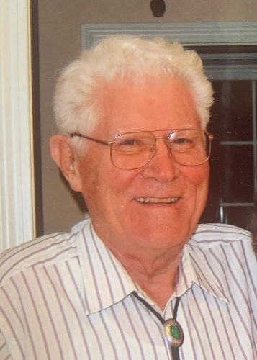
BORN 1925
DIED 2019
FUNERAL HOME
Waters Funeral Home - Concord
50 S. MAIN ST, Concord, NH

Frederick T. (Tad) Comstock, Jr., 94, passed away peacefully on December 16, 2019 at the Boulders at Riverwoods Retirement Community in Exeter, New Hampshire. He was the husband of Georgette (May) Comstock.
Tad was born in Chicago, IL in 1925, a son of the late Frederick T. and Muriel (Fullerton) Comstock. He grew up in South Glens Falls, NY. Following high school, he attended the Newark College of Engineering. After one year, he joined the US Marine Corps where he proudly served in World War II with an engineering demolition unit during the Battle of Iwo Jima.
Following the war, Tad attended the Thayer School of Engineering at Dartmouth where he graduated in 1948 with a B.C.E. degree and in 1951 he received a Navy Ensign Commission in the Civil Engineering Corps.
From 1948 to 1950, Tad worked for the NH Department of Public Works and Highways in Bridge Design and Construction. From 1950 to 1956 he was employed as a structural design engineer with the Anderson Nichols & Company consulting firm. From 1958 until his retirement in 1985, Tad worked in New York, Illinois and New Hampshire for the Federal Highway Administration (FHA) and served his last 18 years with the FHA as the NH Division Engineer and Administrator.
As a professional engineer, Tad served as a member and Past President of many professional organizations including the NH Society of Professional Engineers, the NH Section of the American Society of Civil Engineers and the Dartmouth Society of Engineers. He was also Past President of the NH Federal Executive Association.
During his professional career, Tad earned several prestigious awards including the FHWA Bronze Medal Award for Superior Achievement, the US Secretary of Transportation Silver Medal Award for Meritorious Achievement and the NH Engineer of the Year Award by the NH Society of Professional Engineers.
Tad was also very involved with the community where he was a trustee of the Concord Hospital and the former Visiting Nurse Association, a member and Past President of the Concord Rotary Club, an Eagle Scout and Boy Scout Troop and District Committeeman, and a deacon and long-time member of the South Congregational Church in Concord.
Tad was a devoted husband and had great love for his family and friends. He loved to travel and enjoyed many outdoor activities including tennis, golf, canoeing, fishing and spending time at Bow Lake where he often participated in the sailboat races.
Tad was predeceased by his brother John of S. Glens Falls, NY, and wives Bertha (Wiley) and Martha (Abbot). Loving family members include his wife Georgette May Comstock and children Janet (Mark) Russell of Warwick, RI; Sandra Comstock and Nancy Comstock Bishop of Portland, ME; and Gregg (Lyn) Comstock of Bedford, NH. Stepchildren include Katherine (Jeff) Clough of Loudon, NH; Will (Sue) Abbot of Missoula, MT; Jacqueline (Roger) Brown of Portsmouth, NH, and Colette Nickerson (deceased) of ME. Grandchildren include Jennifer (Aaron) Monastesse and Stephanie Russell of Warwick, RI; Hallie Comstock Repeta of Portland, ME; Ryan (Rachael and daughter Corrina) Comstock of Goffstown, NH; Jeff Comstock of Portsmouth, NH; Heather Comstock of Nashua, NH; and Carl (Marissa) Bishop of Woodbury, CT. Stepgrandchildren include Andrew (Amanda and children Savannah and Duncan) Stone of Loudon, NH; Michael Clough of Barboursville, VA; and Maria Abbot-Johnson (James) and Natalie Abbot of Bozeman, MT.
Calling hours are Thursday, December 19th at the Waters Funeral Home, 50 S. Main St., Concord, NH from 4 p.m. to 7 p.m.
A memorial service will be held Friday, December 20th at the First Congregational Church in Hopkinton, NH at 12 Noon.
Burial will be private.
In lieu of flowers, memorial contributions may be made to the American Red Cross (https://www.redcross.org/donate/donation.html/).

Published by Concord Montior on Dec. 17, 2019.

