Larry Darnes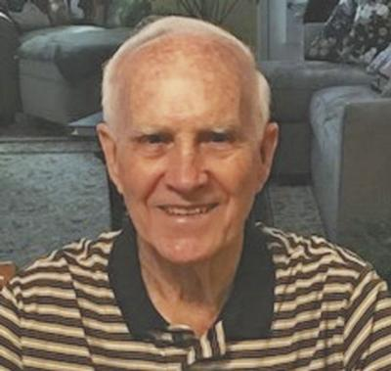

Larry Darnes, age 81 of Maryville, passed away on Saturday, Jan. 30, 2021 at Blount Memorial Hospital.
He graduated from Greenback High School where he was captain of his basketball team, and was also known as “Mr. Greenback.” He got his undergrad in engineering at the University of Tennessee, Knoxville, and his master’s degree in engineering from the University of California, Berkeley.
Larry was retired from the Federal Highway Administration with over 35 years of service.
He was an avid golfer and enjoyed playing with his Tuesday group. He enjoyed drawing, yard work, wildlife and bird watching.
Larry was a devout Christian who worshipped in faith at Fairview United Methodist Church.
He was preceded in death by: his parents, Robert and Birdie Darnes; his sister, Loma Farner; and his brother, Ray Darnes.
He is survived by: his beloved wife of almost 50 years, Jean Darnes; Sons and daughter-in-law, David and Nikki Darnes, and Eric Darnes; Grandchildren, Brandon, Evan, and Hailey; Brother, Bobby Darnes; Many nieces and nephews.
The register book was available on Thursday, Feb. 4, 2021, from 1 p.m. until 5 p.m. at Smith Funeral & Cremation Service in Maryville. A private graveside service will be held at Cane Creek Cemetery in Tellico Plains.
In lieu of flowers, memorial donations may be made to one of the following: The First Tee, www.thefirsttee.org; American Heart Association, www.heart.org; Blount County Humane Society, www.blountcountyhumanesociety.org; or Fairview United Methodist Church, www.fairview-umc.org, in memory of Larry.
Smith Funeral & Cremation Service, Maryville, 865-983-1000, www.SmithFuneralandCremation.com, in charge of arrangements.

