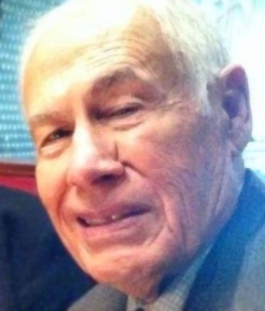
PETER CRIVELLO Age 88, of San Bruno, CA, passed away peacefully Monday, July 27, 2020. Mr. Crivello was born in Pepeekeo, Hawaii, a son of the late Peter Dale Crivello and Mary Moniz Crivello. He was a retired civil engineer for the Federal Highway Administration in San Francisco, California, and also honorably served in the Army of the United States. Survivors include his wife of 61 years, Irene N. Crivello, his children and family, the late Michael Crivello, Renee Crivello Lee and Ron Vargas, granddaughter, Nicole Lee, and Galen and Andrea Crivello, other grand- children, and his sister, Blanche Iaukea, of Kailua, Oahu. Private services and interment followed at Skylawn Memorial Park in HMB. Condolences may be sent to 2501 Princeton Drive, San Bruno, CA 94066.

