Douglas Norman Head
1943 - 2021
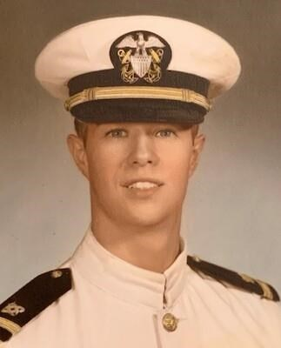
BORN 1943
DIED 2021
FUNERAL HOME
Flanner Buchanan – Carmel
325 E Carmel Dr
Carmel, IN
Douglas Norman Head
Carmel - Douglas Norman Head, 77, of Carmel, Indiana passed away March 13, 2021. He was born October 1, 1943, in Great Falls, Montana, the son of the late Norman Bradbury and Ellen Viola (Sibley) Head. He married Linda Dare Gumprecht on September 13, 1966.
Doug received his Bachelor of Science degree in Civil Engineering from Washington State University. After graduation, Doug served honorably in the United States Navy. He entered into Naval service from Walla Walla, Washington and attended Naval Officer Candidate School (OCS) at Naval Base Newport, Rhode Island. He also attended Civil Engineer Corps Officers School. During his four years of active duty service he was awarded the National Defense Service Medal and was advanced to Lieutenant in April 1970. He retired as P.E. with the Federal Highway Administration. He also served in jury trials as an expert witness and was active with crash analysis cases under his firm, Head Engineering. He was a member of the American Society of Civil Engineers.
Doug was an active member of The Church of Jesus Christ of Latter-day Saints and served a Family History Mission. He was a Boy Scout and later served as a scout master and a member of the local council. He loved to go camping, fishing, bird watching, and cultivating tulips.
He is survived by his loving wife of 54 years, Linda Dare Head; 11 children, Debora (Bruce) Bonney, Rebecca (Byron) Law, Andrew Head, Cherie (Christian) Starnes, Paula (Ryan) Eblin, Aaron Head, Misha (Andrew) Horstman, Adam (Lindsay) Head, Elizabeth (C.J.) Humes, Alanna (Hiram) Holt, and Alexander (Melissa) Head; 23 grandchildren; 7 great grandchildren; two sisters-in-law, Virginia Gumprecht and Nancy (Stuart) Yeager; and several nieces and nephews. He was preceded in passing by a grandson, Michael Thomas Bonney.
Due to Covid restrictions, services will be private. A live stream link will be available on Douglas's tribute site at flannerbuchanan.com. Memorial contributions may be directed to https://philanthropies.churchofjesuschrist.org/familysearch. Arrangements were entrusted to Flanner Buchanan - Carmel.

