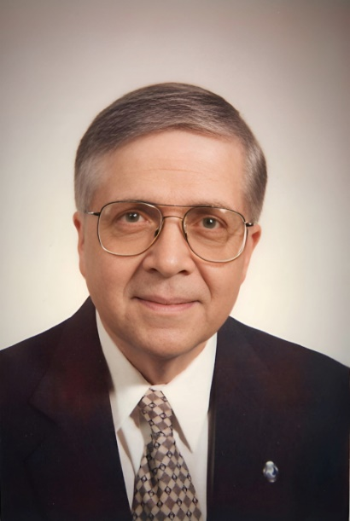

Official Obituary of

Thomas John Ptak
January 1, 1940 ~ May 24, 2024 (age 84)

Thomas Ptak Obituary
It is with heavy hearts that we announce the passing of Thomas John Ptak; a beloved husband, devoted father, and cherished grandfather. He peacefully departed this world on May 24th, 2024, leaving behind a legacy of love, kindness, and unwavering dedication.
Born on January 1st, 1940 to Thomas and Mary (Kososky) Ptak in West Virginia, Tom moved to South Milwaukee, Wisconsin when he was three years old. He attended South Milwaukee High School and graduated from the University of Wisconsin with a Bachelor of Science and a Master’s Degree in Civil Engineering.
Professionally, Tom enjoyed a long and distinguished career at the Federal Highway Administration. He started in the training program with Bureau of Public Roads in 1963 and served in many capacities in California, Indiana, Illinois, Utah, Tennessee, Missouri, Kansas, and Virginia. He received many awards and advanced to Senior Executive Service before retiring in Kansas in 2000.
Tom lived a life filled with joy, adventure, and accomplishment. On January 20th, 1962 he married Patricia Ann Eaton, embarking on a journey of sixty-two years of cherished companionship and devotion. Together, they shared a bond, weathering life’s storms with grace and resilience.
Tom was a pillar of strength and love for his children, Alison (James), Andrea (Bruce), Elizabeth, and Jennifer. His unconditional love and support shaped their lives in profound ways, instilling in them values of compassion, integrity, and perseverance. Tom’s devotion was particularly evident in his loving care for Jennifer, who required life-long support. His selflessness and dedication as a father knew no bounds, leaving an indelible mark on each of his children’s hearts.
As a grandfather to Rachel (Patrick), Ashley (Brian), Candace, Cecily (Andrew), and Brooklyn, Tom delighted in their laughter, celebrated their milestones, and provided them direction. His love extended to his great-grandchildren, Jacob, Thomas, Molly, Emily, Finley, Brooks, and Cameron, who brought immeasurable joy and happiness into his life.
Tom was a dearly loved brother of Elsie (David) Kromenaker, and uncle to nieces Susan and Sherri. He was preceded in death by Thomas and Mary Ptak, and Sandra Henry.
Tom found solace and joy in his passions. An avid fisherman, he found peace in the tranquil waters, casting his line amidst nature’s beauty. His annual trips up North and to Canada were cherished moments of camaraderie and relaxation. Work was also his passion, and even his hobbies became personal challenges to master. Over the years he became proficient in woodworking, gardening, photography, clockmaking and various tech interests. He single-handedly refinished basements, including electrical, plumbing, and tile work. No job was too hard to tackle.
In honoring Tom’s memory, let us celebrate the life he lived, the love he shared, and the profound impact he had on all who knew him. May his soul find eternal peace, and may his memory be a blessing to us all.
Mass of Christian burial will be held at St. Joseph’s Catholic Church, 11311 Johnson Dr., Shawnee, Kansas on June 1st, at 11:30am, with a visitation starting at 10:30 prior to the service. Burial will be at a later date at Forest Hill Memorial Park, in Oak Creek Wisconsin. In lieu of flowers, memorials appreciated to Jennifer’s program at L'Arche Heartland.
Forever in our hearts, forever remembered, forever loved.
The Ptak Family

