Ellen Webster Baynard
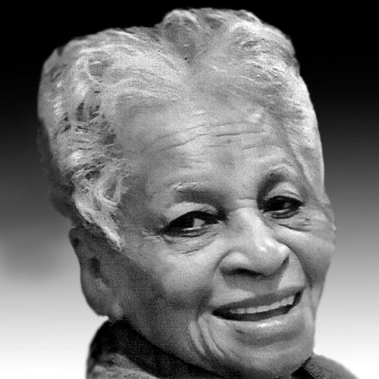
Ellen Webster BAYNARD (Age 92)
On Tuesday, December 12, 2023, Ellen peacefully accepted her fly away wings in her native Washington, DC. She is survived by daughter, Lynn B. Pittmon, son, Frank C. (Deadrine) Baynard, Jr as well as four grandsons, four granddaughters, four brothers, three sisters and a host of nephews, nieces, cousins, in-laws and friends.
Farewell ceremony will be held on Friday, December 22, 2023 at St. Stephen & Incarnation Episcopal Church 1525 Newton St., NW, Washington, DC. Visitation begins at 10 a.m. and Requiem Mass begins at 11 a.m.

