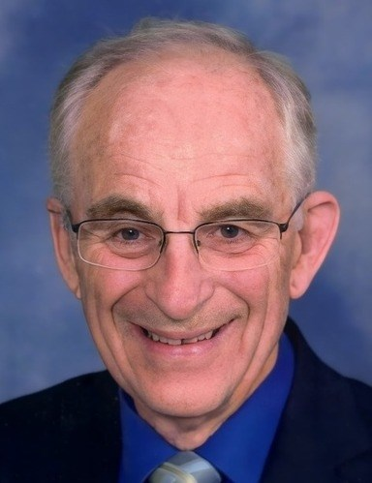
Byron Cecil Bassett
January 28, 1936 - January 31, 2025
Byron Cecil Bassett, passed away Friday, January 31, 2025, just three days following his 89th birthday.
A memorial visitation and fellowship time will be held 1 to 3 p.m., Sunday, February 9, 2025 at Feigum Funeral Home. A Memorial Celebration of Life Service will begin at 10 a.m., Monday, February 10, 2025 at the First Congregational United Church of Christ with inurnment following at Riverside Cemetery. Cecil's service may also be viewed online at www.feigumfh.com.
Byron Cecil Bassett, son of Floyd and Garnett (Bevier) Bassett, was born January 28, 1936, in Lyon's Oregon, where he grew up and attended school, graduating from Stayton Union High School in 1954. Following his graduation, Cecil attended the University of Oregon where he received a degree in accounting. He was united in marriage to Judith Norton on September 7, 1957. The couple moved to Salem, Oregon where he began his career at the Federal Highway Administration. Cecil and Judy had three children: David, Mark and Marianne. In 1968 the family moved to Pierre, SD, where he continued his career working for the Federal Highway Administration for the next 35 years until his retirement in 1991. Following his retirement, Judy's teaching career took them to Madison, Wisconsin for a short time before returning to Fort Pierre, SD to be closer to their family. The couple later moved to Rapid City where they continued to live until Judy passed away in 2020. Cecil once more returned to Pierre to be closer to family until the time of his passing.
Cecil was a very talented musician who played the piano, organ and accordion. He enjoyed arts and crafts including latch hook and needlepoint and put together many jig saw puzzles. Together with Judy, they enjoyed square dancing, camping and traveling. They took trips to Japan, Germany, Newfoundland, Mexico, Hawaii and all over the continental United States. They also enjoyed 20 years wintering in Texas.
He is survived by three children: David (Melinda) Bassett of Corpus Christi, TX, Mark (Ruth Sweeten) Bassett of Bremerton, WA and Marianne (Mike) Gabriel of Pierre, SD; five grandchildren: Alexander and Abigal Bassett of Corpus Christi, TX, Brooke (Dane) Christensen of Starbuck, MN, Carlee (Tony) Wika of Ipswich, SD, and Katie Sanders of Sioux Falls, SD; two great-grandchildren: Liv Christensen and Connor Wika; sister-in-law: Ursula Bassett of Wenatchee, WA; nieces: Nancy (Ron) Graham of Woodland, WA and Debbie (Kevin) Healy of Portland, OR; and nephews: Jerry (Rebecca) Bassett of Wenatchee, WA and Francis (Cindy) Bassett of Florence, AZ. He was preceded in death by his wife: Judy Bassett; brother: Dale Bassett; brother-in-law: Sterling (Dorothy) Norton; his parents and his grandparents.
In lieu of flower, memorials may be directed to First Congregational United Church of Christ. Condolences may be conveyed to the family at www.feigumfh.com.

